Nathan Fenske

02/27/2022

Intro To Python

Assignment 5

**Introduction**

The goal of this assignment is to allow the user to create a CD inventory list by presenting a menu he/she may interact with. The menu allows the user to add a CD with the artist, view the current inventory list, save it, and exit.

**Summary**

The following program, shown below in Figure 1, presents the user with a menu. When the user makes his/her selection, the program runs through a series of if and elif statements to determine what condition is true. If no conditions are true, the program displays “Invalid selection. Program will terminate.” The user has the option to add a CD, view the current inventory list, save the list, and exit the program

Figure 1: The program

**Details**

**Main Menu**

The code below in Figure 2 presents the user with the menu to the inventory program

Figure 2: Main Menu

**Selection 1**

If the user selects “x”, the program exits. Figure 3 displays the code below.

Figure 2: Selection 1

**Selection 2**

If the user selects “l”, the program retrieves the data in the text file and displays the results as seen in Figure 4. A dictionary is created, creating a key between the values and the variables.

Figure 4: Selection 2

**Selection 3**

If the user selects “a”, the program prompts the user to input first a CD name and then the artist name. Once inputted, the program saves the values to memory in a dictionary. Figure 5 displays the code below.

Figure 5: Selection 3

**Selection 4**

Figure 6 shows the code used to display the current data to the user if the user types “i”.

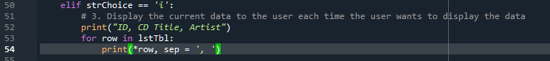

Figure 6: Display Data

**Selection 5**

If the user selects “d” the program allows the user to delete an entry as seen in Figure 7.

Figure 7: Delete Data

**Selection 6**

If the user selects “s” the program opens the text file, writes to it, saves it, and closes it as seen in Figure 8.

Figure 8: Save File

**Invalid Selection**

Finally, should the user type in character or number not in the predetermined selection, the user will informed as such and the program will terminate. Figure 7 shows the code for this.



Figure 9: Invalid Selection